Paneer Butter Masala

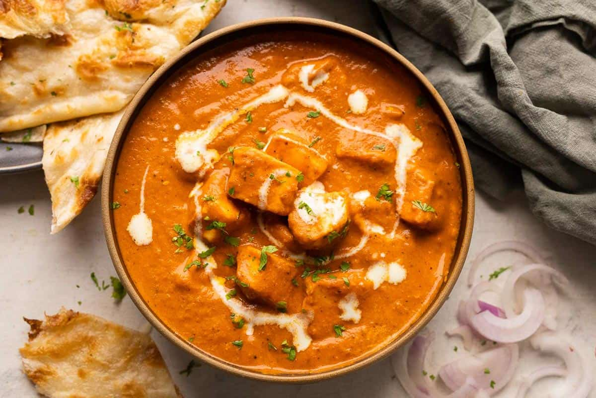
Ingredients:

  - For the tomato paste:
- 6 tbsp oil
- 6 tbsp butter
- 15 cloves
- 6 pods cardamom
- 6 onion (sliced)
- 6 clove garlic
- 3 inch ginger
- 9 tomato (sliced)
- 45 cashews
  - For the gravy:
- 6 tbsp oil
- 6 tbsp butter
- 3 bay leaf
- 1 chili
- 3 onion (finely chopped)
- 1.5 tsp turmeric
- 2 tsp chilli powder
- 3 tsp coriander powder
- 1 tsp cumin powder
- 1.5 tsp garam masala
- 3 tsp salt
- 6 tbsp cream
- 1-2 tsp honey (optional)
- 1.5 kg paneer cut in medium sized cubes
- 3 tsp kasuri methi
- Coriander (finely chopped)

Instructions:

  - How to make the tomato paste:
- Firstly, in a large pot heat the oil and the butter. Add the oil first to make sure that the butter doesn’t burn.
- Add the cloves and cardamom and sauté on low flame until it turns aromatic. (Usually takes 1-2 mins)
- Now add the onions, garlic and the ginger and cook until the onions shrink slightly.
- Add the tomatoes and the cashews and cook for 2-3 mins.
- Take the pot off the pan and let it cool.
- Once cooled, transfer everything to a blender and blend it to a smooth paste. (Add a little bit of water to the blender if it doesn’t blend easily)
- The tomato paste is now ready! Store it separately, as it will be needed later on.

  - How to make Paneer Butter Masala:
- In the same pot which was used to make the tomato paste, add the oil and the butter along with the bay leaf and the chili and cook for 1-2 mins on low flame.
- Now add the finely chopped onions and cook until the onions turn golden brown.
- Keeping the flame on low, add the powdered spices and salt and keep cooking for until the spices turn aromatic. (2-3 mins)
- Now add the tomato paste that we had prepared earlier and mix it well. Cook on medium heat for 5-7 mins till the oil separates.
- Add some water to adjust the consistency. (Don’t make it too watery. We’re aiming for a relatively thick sauce)
- Add the cream now and mix well. If the sauce is too spicy add the honey to balance out the spices.
- Finally, add the paneer cubes and let it cook on low heat to 5-10 mins so that the paneer absorbs the flavour.
- Garnish the dish with some cream, kasuri methi and coriander.
- Paneer butter masala is now ready to eat!

